**JOBSHEET 11**

**Linked List**



**Name**

Sherly Lutfi Azkiah Sulistyawati

**NIM**

2341720241

**Class**

1I

**Major**

Information Technology

**Study Program**

D4 Informatics Engineering

**Lab Activity 1**

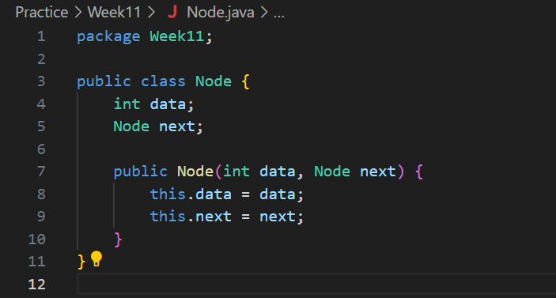

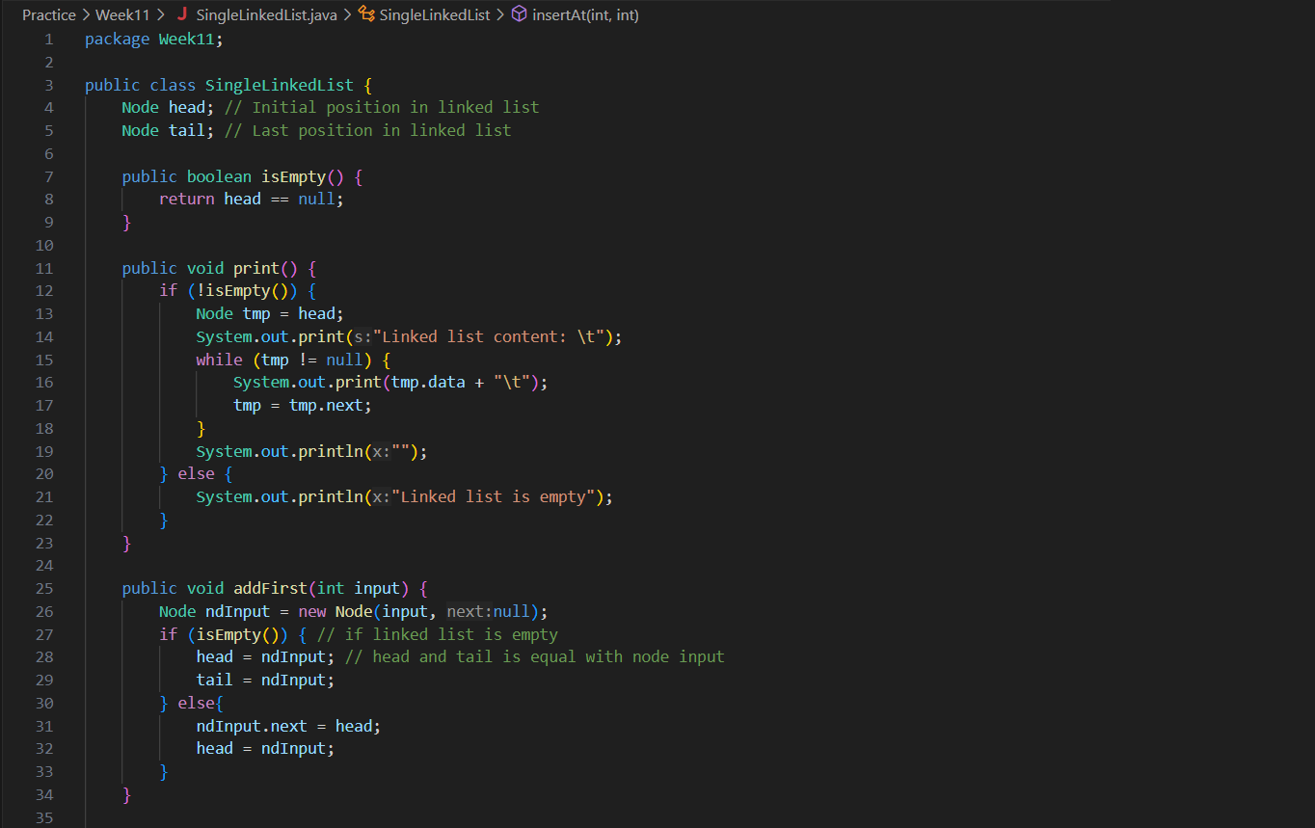

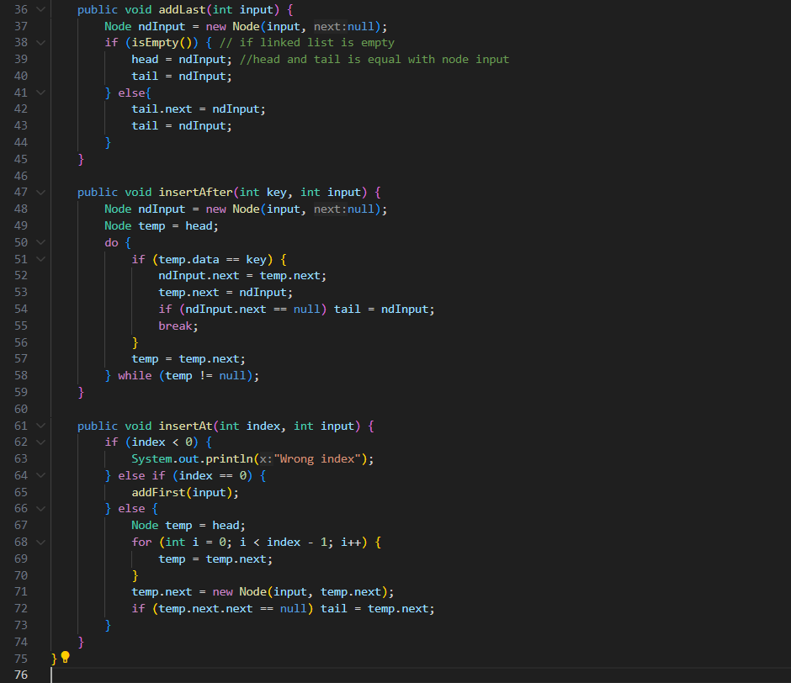

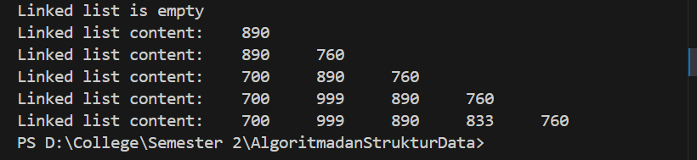

**Question**

1. Why the output of the program in first line is “Linked list is empty”?

- Karena blm ada node yang ditambahkan

1. Please explain the usage of these following codes in:



-

1. In SingleLinkedList, what is the usage of this following code in insertAt?



**Lab Activity 2**

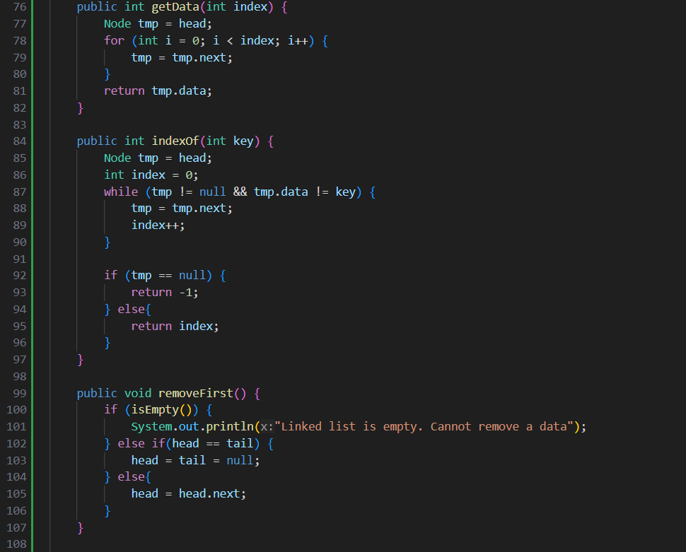

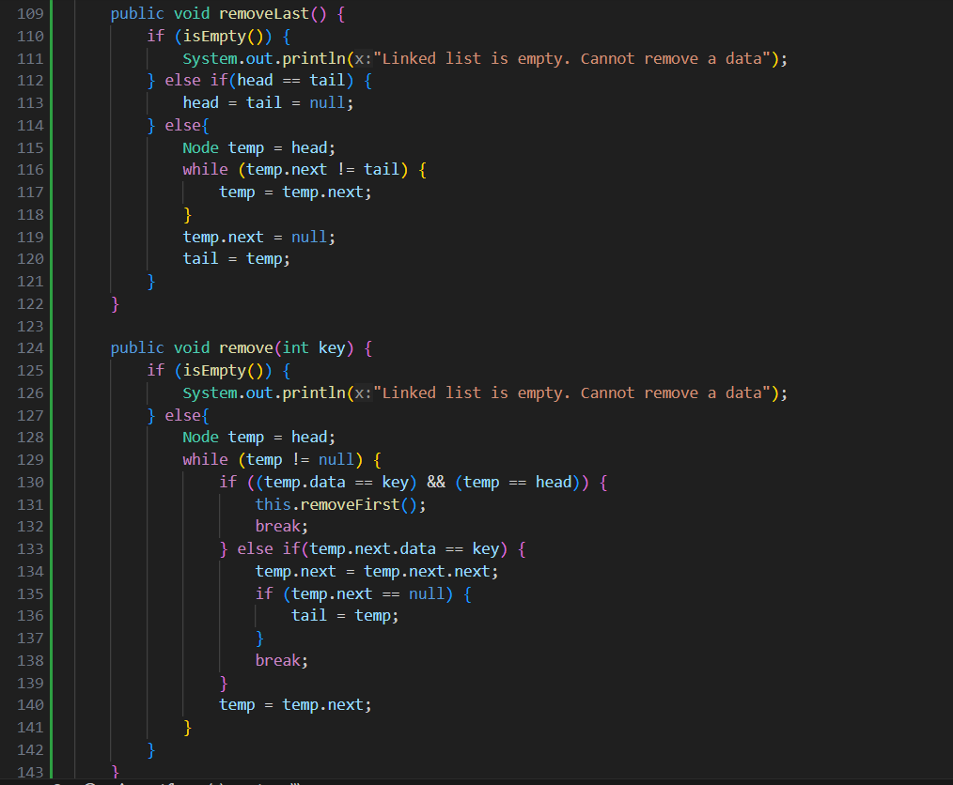

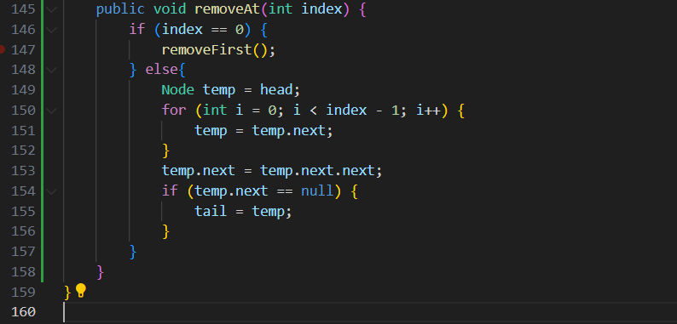

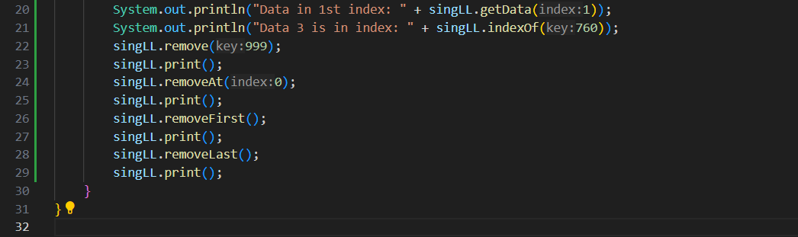

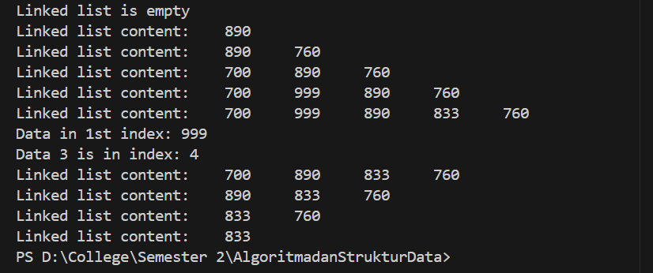

**Question**

1. Why we use break keyword in remove function? Please explain
2. Please explain why we implement these following codes in method remove



1. What are the outputs of method indexOf? Please explain each of the output!

**Assignment**

1. Create a method **insertBefore()** to add node before the desired keyword
2. Implement the linked list from this following image. You may use 4 method of adding data we’ve learnt

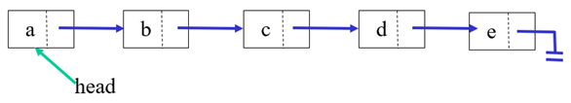

1. Create this following **Stack** implementation using Linked List implementation

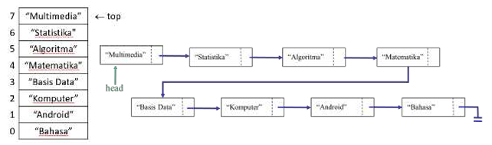

1. Create a program that helps bank customer using linked list with data are as follows: Name,address, and customerAccountNumber
2. Implement **Queue** in previous number with **linked list** concept